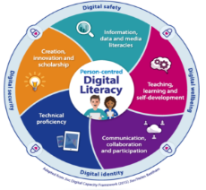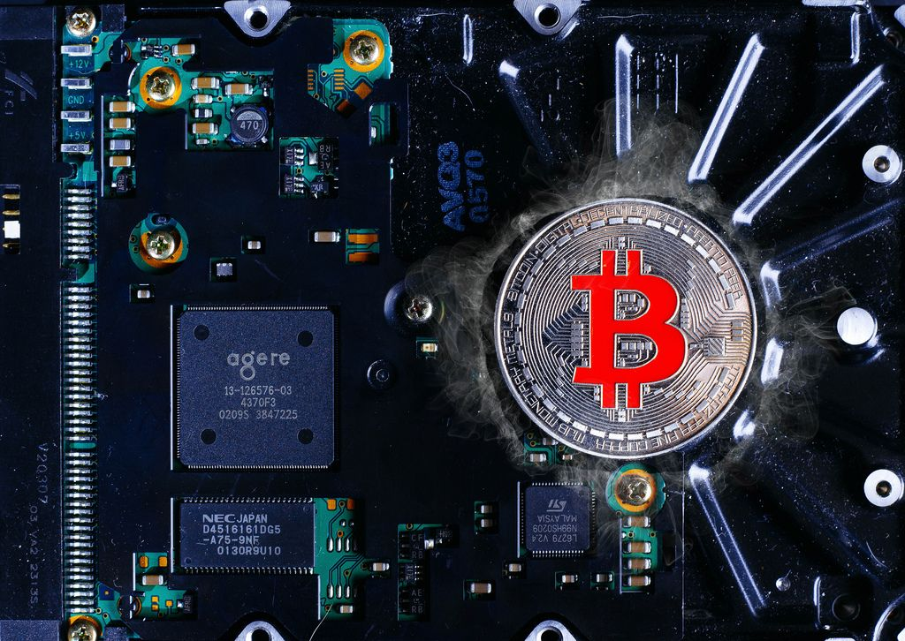

Programs Offered

*Robotic/tinkering

*Computer hardware

*Mobile Repairing

*Cooking/Hospitality

*Beauty & Wellness

*stitching & cutting

*Electrical Troubleshooting

*Two-Wheeler Repairing

*Mobile Journalism

*Computer science

*Call Center/BPO

*Logistic

*Data Digitization

*National Farming Market connect

*Banking

[WWW.literacyindia.org](http://WWW.literacyindia.org)

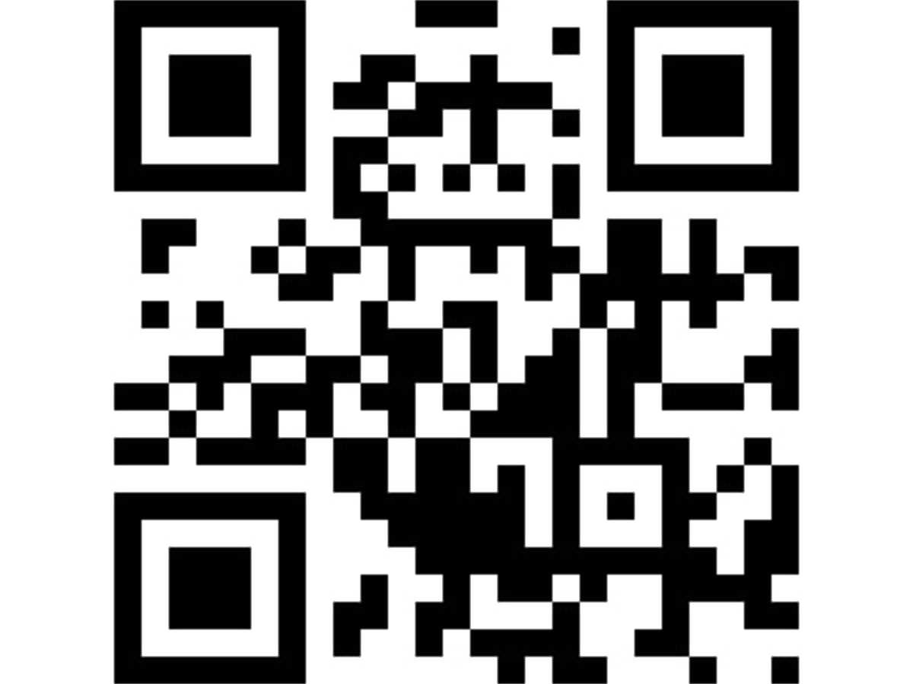Contact No -8588853380

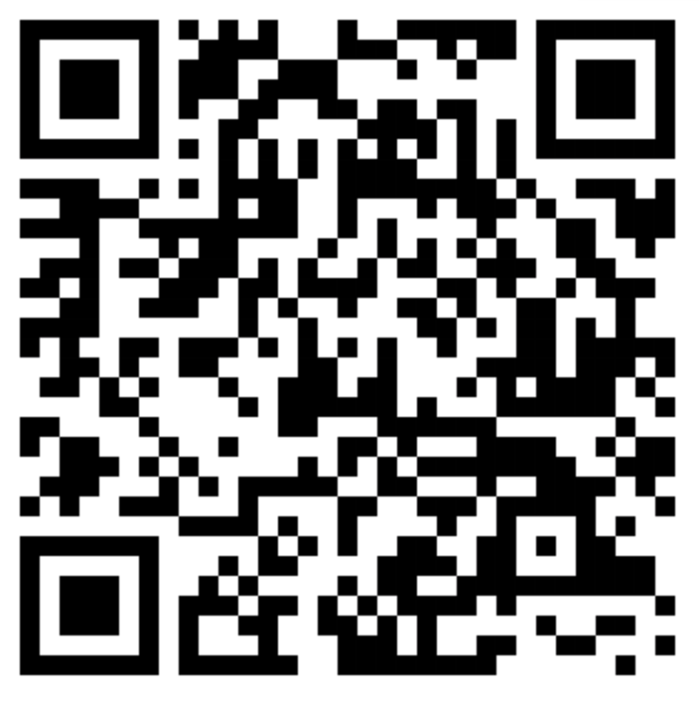



Limited seats

Session starts from

January 2024

Register Now

ggbb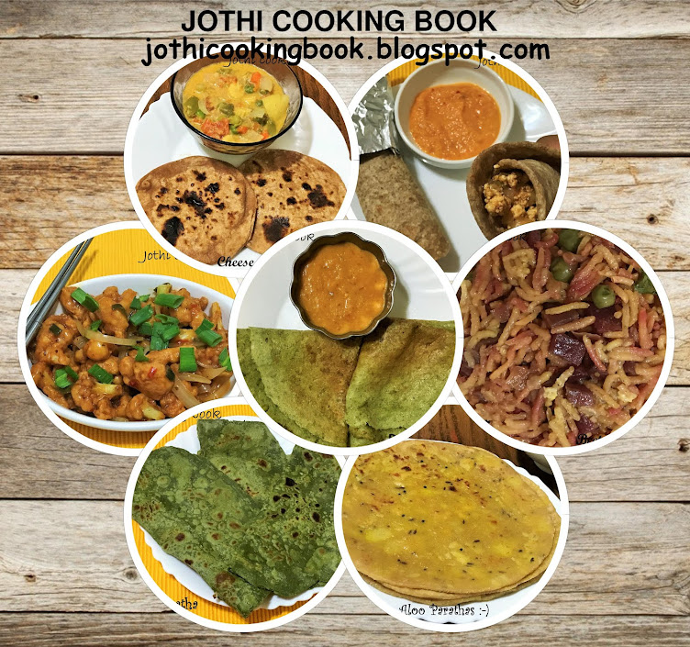

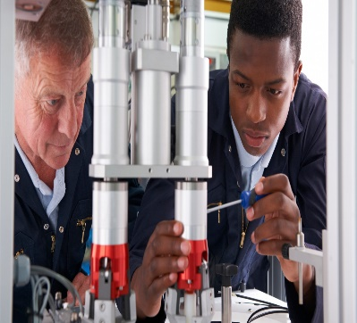

[This Photo](https://www.mynextmove.org/profile/summary/17-2141.00) by Unknown Author is licensed under [CC BY](https://creativecommons.org/licenses/by/3.0/)

LITERACY INDIA COMMUNITY COLLAGE (LICC)